Accelerate Comments Instructions and Guidance for Staff
Contents

1. Accelerate Comments 2
2. Accessing Accelerate 3
3. Accelerate home page 4
4. Comments page 5
5. Responding to a comment 7
6. Adding a comment 8
7. Like/dislike buttons 9
8. Notification settings 9
9. Reporting comments 9
10. What sort of feedback should students use Accelerate for? 10
11. Tips 11
12. Support for academics 11
13. Use of data 12
14. Help and contact details 13

1. Accelerate Comments

Accelerate comments is a tool for students and lecturers to engage in dialogue about modules. Students can use Accelerate to comment and raise various issues with their modules. This could include problems with teaching or assessment, or general questions about the material. Discussion then follows a collaborative approach where staff and students respond to questions as appropriate and help each other’s understanding. Additionally, Accelerate allows users to rate questions and comments to identify the most useful questions and answers.

2. Accessing Accelerate

Access Accelerate through the button on your ELE page or via https://accelerate.exeter.ac.uk/login.
Login screen
On the login screen you are presented with two options. You can either login using Single Sign On or you can login with username and password.
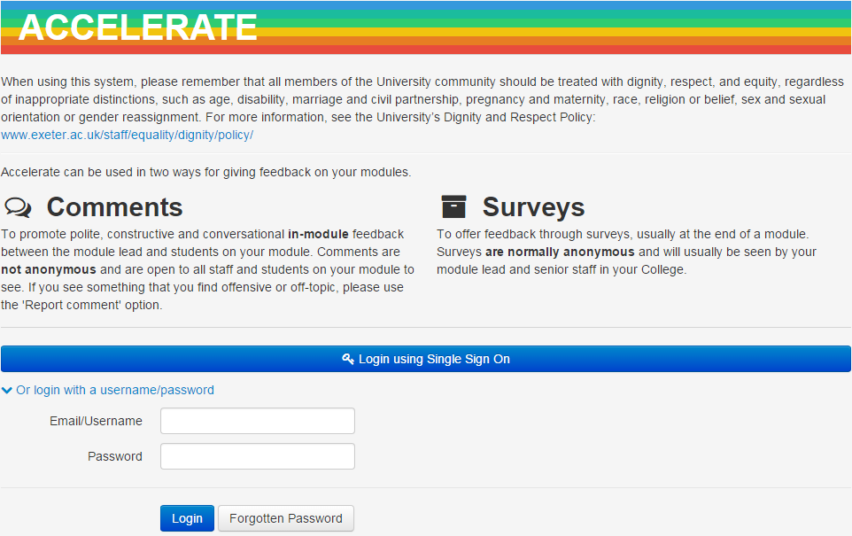

3. Accelerate home page

On the Accelerate home page staff have the following options:
  - View Module
All the modules you have admin rights to will be listed as options in the grey box in the middle of the page. If you click on ‘View Module’ you will be able to see information on the module such as start dates and staff access levels to Accelerate.
  - View Students
If you click on ‘View Students’ you will be able to see all the students who are registered to this module. These students will be able to comment on it through Accelerate.
  - View Comments
Clicking on this will take you to all of the comments students have made on modules.
  - Staff
This drop down menu contains the following options; reported comments, question sets (under development), questions (under development), surveys (under development), module reporting (under development) and college reporting (under development).
The option for reported comments allows you to see which comments have been reported by students so you can delete them as appropriate.

4. Comments page

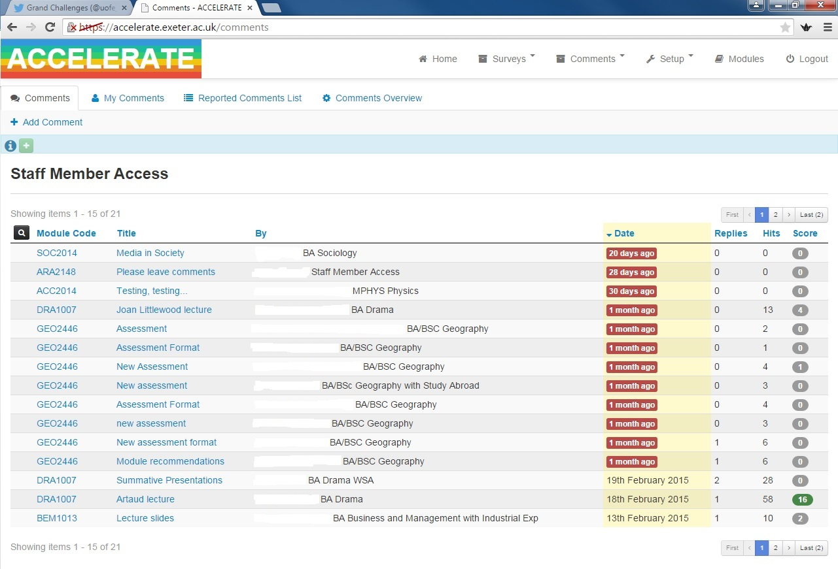
When you access the comments page you will be able to see all of the comments that students have posted and the modules they relate to. To access and respond to a particular comment click on the title of the relevant comment.
You can see how many hits each comment has and also its score. (Score = the number of students who have clicked like on a comment minus the number of students who have clicked dislike on a comment.)
To return to the home screen just click on the Accelerate logo.

5. Responding to a comment

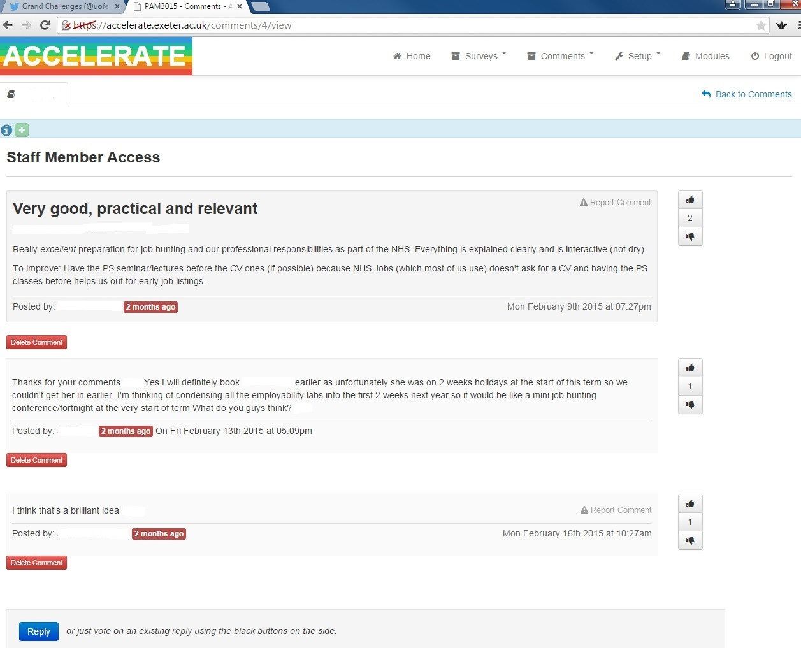
When you click on an individual comment you have the option to either add reply or to delete the comment if it’s inappropriate.

6. Adding a comment

To add a comment to a module, navigate to the comments page from ‘Comments’ tab. Select ‘+ Add Comment’ at the top left of the screen, this will take you to the following page:
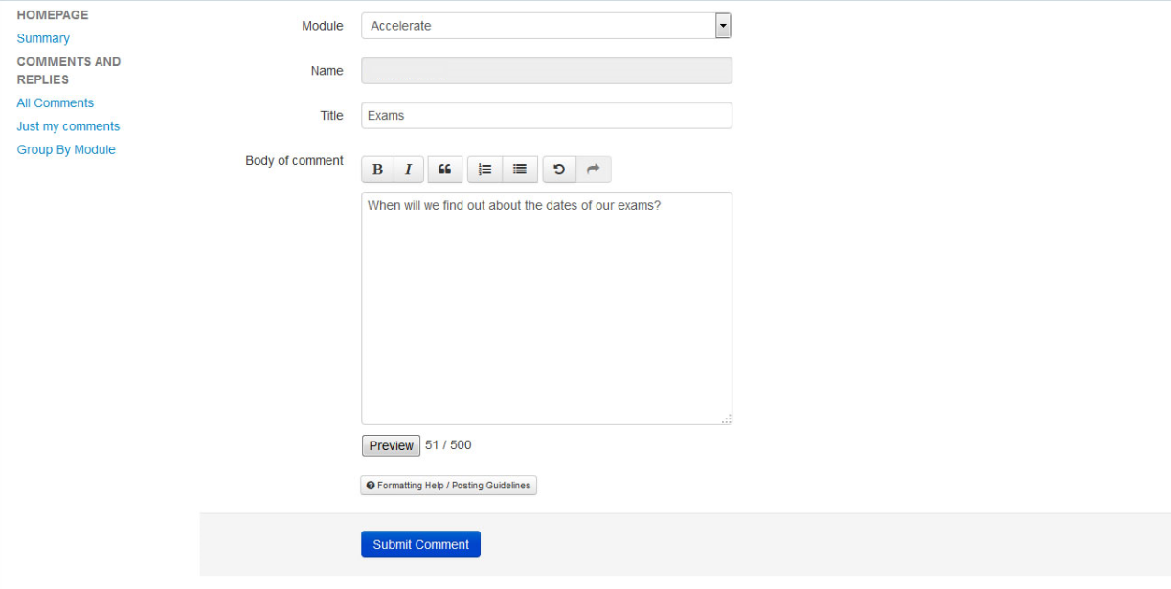
- Select the module you wish to comment on.
- Your name will be populated for you
- Give the comment a title; it helps if you give some indication of your comment/question in the title e.g. ‘Enjoying the lectures?’
- Complete the comments box, expanding on your comment as well as referencing any other relevant information.
- ‘Submit Comment’

7. Like/dislike buttons

On the right hand side of the comment you will see symbols showing a thumbs up and a thumbs down. Students have the option to agree or disagree with an individual comment, rather than posting again to make the same point. The number between the thumbs is the score for the comment. The score is the number of people who have clicked like on a comment minus the number of people who have clicked dislike on a comment.
If there is a question that has been posted that you agree or disagree with, you can show this by clicking the like/dislike buttons.
If there is a response which you find useful you can also show this using the like/dislike buttons.

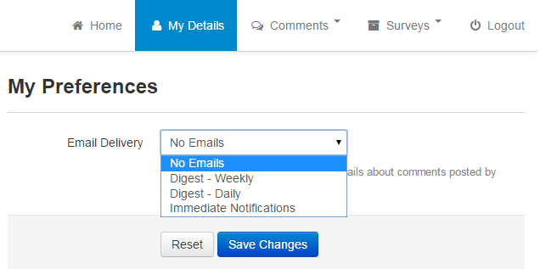
8. Notification settings

Accelerate has several different levels of notification settings that allow staff to control how often they are informed of new comments. You can set the system to inform you by e-mail immediately when a comment or reply is posted, once a day with a list, once a week with a list, or no e-mails at all. This allows you to balance the system with other commitments. You should make it clear to students how often you aim to check comments.

9. Reporting comments

All comments entered onto the Accelerate system are expected to comply with the University’s Dignity and Respect Policy: http://www.exeter.ac.uk/staff/equality/dignity/policy/. If a comment is rude or otherwise offensive you can delete the comment. You will also be informed should a member of your student cohort find a posted comment offensive. If the comment is directed at you, you may wish to screenshot this.

10. What sort of feedback should students use Accelerate for?

Students should use Accelerate for polite, constructive feedback to their module leader. Comments are open to all staff and students on your module to encourage conversation about topics.
Some examples of comments students could post are:
- I really liked the short pairwork activity in the middle of last week’s lecture. It made the lecture much more fun and interesting.
- Asking us to find the answers to three key questions while we were watching the video made it much easier to focus on the important bits – great idea to do this!
- Thanks for a great class last week – it was really inspiring to hear about your research.
- Could you go over Einstein’s theory of relativity again next week? I’m not sure I’ve really got it yet.
- You mentioned an article about the theatre of the absurd – please can you give us the full reference?
- There only seems to be one copy of Buggins et al in the Library; can the Uni order some more copies?
- Buggins et al is really difficult to follow. Is there an easier set text?
- Room 101 is really cramped. Can we have our lectures somewhere else?
- Please can you explain what the mid-module assignment question means?
- How many references should we use for the end of term essay?
- Some people at the back of the room were texting and chatting all through the lecture last week and it’s very distracting for the people sitting near them. Can we have some class ground rules about not doing this?
- I couldn’t find the reading list you mentioned. Is it on ELE?
- You said we would get info on our assignment this week. Can you say when?
- I missed a session this week because I was ill. What’s the best way to catch up? It would be useful if all lectures were recorded.
- Are we going to have revision sessions before the exam?
- It’s hopeless when only a few of us prepare for the seminar. Is there a way of getting everyone to do this?
- I need some more help setting up my experiment. Could you go over it again next lab session?

11. Tips

Here are some tips for managing Accelerate use effectively:
- Set limits and be explicit with students as to your availability. (“I read and respond to comments from Monday to Friday from 9-5 and try to respond to all comments within 2 days” for example).
- Establish a set of guidelines for appropriate use of Accelerate. You could ask students to find some good netiquette guidelines online or ask them to create their own.
- Be very specific about the quality and level of posts you expect. Be prepared to demonstrate and reiterate what you want in several ways for students who are unfamiliar with giving feedback online.
- Be prepared to spend some time during the first week helping students access and navigate Accelerate.
- Set aside specific times to read and respond to comments.
- Discourage students from emailing you when they could be posting their questions to the whole group. Encourage participants to use Accelerate to share knowledge when they have it and ask for what they need.
- Besides being a source of information you are also a participant in Accelerate. Be careful about how much you post yourself - an overly active facilitator can squelch student participation.
- Please refer to the University’s IT Regulations and the Acceptable use policy which can be accessed at http://as.exeter.ac.uk/it/regulations/regs/ for information on acceptable IT use.

12. Support for academics

One of the reasons that Accelerate is not anonymous is to try to reduce the number of non-constructive criticism from students. However, from time to time, staff may receive negative comments from students.
If a comment is negative, but written in a polite manner, we would recommend that you:
- Thank the student in a polite way for their feedback.
- Respond appropriately to their comment. For example, if you think that they are making a fair point, recognise this and explain what changes you will make in the future. If you don’t think that their point is valid, explain why with reasoned arguments.

If a comment is rude, you may want to consider the University’s Dignity and Respect Policy: http://www.exeter.ac.uk/staff/equality/dignity/policy/. As members of the University community, students are expected to show respect for staff and when the behaviour of a student falls below the expected standard, Disciplinary Procedures should be instigated. See http://www.exeter.ac.uk/staff/policies/calendar/part1/otherregs/discipline/ for further information.

13. Use of data
The following paragraphs indicate the data use policy for the Accelerate in-module comments feedback tool:
a) Non-anonymised qualitative data (comprising name, staff or student number and course/module participation and comments) will be used for the following purposes and with the specified groups of people:

- Data use for the purposes of ensuring that the system is working correctly and developing and improving the Accelerate system:
  - System Administrators (as appropriate in each College, Accelerate project staff and Exeter IT staff).
  - Switch Systems. Data will only be used by Switch Systems in accordance with the terms of their contract with the University.

- Data use for the purposes of gathering and using module feedback:
  - Module staff including module leaders, other lecturers and PTAs.
  - Registered students on a module (including personal data of other students).

- Data use for disciplinary action:
  - Reported comments may be seen by APS staff in the case of disciplinary action against a student.

- Data use for other systems: Data could be integrated into other specified systems in the future e.g. data could be a potential source for the student analytics project. Data use by these systems will be approved on a case-by-case basis and students and staff using Accelerate will be consulted about any changes to data use.

b) Anonymised non qualitative statistical data, e.g. how many comments posted by module, how many different students have posted on the module etc. will be used by the following groups to track system usage rates:

- System Administrators (as appropriate in each College, Accelerate project staff and Exeter IT staff).
- Switch Systems. Data will only be used by Switch Systems in accordance with the terms of their contract with the University.
- SSLC student reps
- Directors of Education
- ACMEs
- ADEs

c) Comments data will not be used for the purposes of performance management of staff.

d) Note that the University is subject to the Freedom of Information Act and may be obliged to disclose information held within the system.
e) Data will be stored in servers hosted by the University.
f) Data will be stored for 5 years from the end date of the module and will then be deleted annually. Students and staff cannot delete their own comments after a module has closed. However they will be able to see the comments from previous modules that they were registered on until the data is deleted. Data will follow individuals, not modules – for example, if a new staff member takes over a module, they will not see comments from previous iterations of the module.
g) A Code of Practice on data use from feedback systems will be developed in the Autumn Term 2015.

14. Help and contact details

If you have any questions, comments or technical difficulties, please email accelerate@exeter.ac.uk and we will get back to you as soon as we can.

