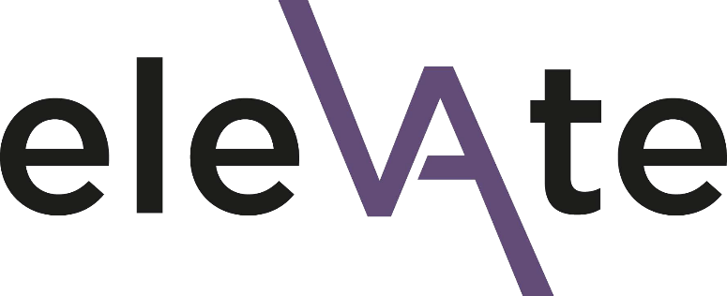

Elevate 2024 Application Form

Introduction
Thank you for your interest in the Elevate programme. Please complete this form in full. Kindly note that completing this form does not guarantee a place on Elevate.
You will need to have a conversation with your line manager about your application and ask them to complete a separate endorsement form to support your application. We will not share any of the details you provide in this application form with your line manager. However, you may choose to do so yourself, if you wish.
The deadline for your application and the line manager endorsement form is 23:59 on Wednesday 1st November 2023. Please send your completed form to edi@exeter.ac.uk You will be informed of the outcome by the end of November 2023.
If you have any questions about the application process, need support in completing it or are experiencing any technical difficulties, please contact Beau Bell, EDI Manager: b.bell@exeter.ac.uk

Data protection
All information you provide in this application form will be treated as confidential and will be held in accordance with GDPR regulations. Please see the University’s privacy notice for further information. Your data will be shared with the selection panel (details available on request) and thereafter used for reporting purposes only.
☐ I consent to my data being used in this way

Programme dates
If your application is successful, you are required to attend all the Elevate programme dates
- By ticking this box I confirm that I am available to attend all dates.

Applicant Details
First name
Surname
Job title
Contact email
Your grade
Faculty and Department
Academic or Professional Services

What is your ethnic background?
Note: Reporting categories are used here for comparison with overall university demographics in our evaluation of inclusive practice. We recognise the limitations of this approach which does not capture nuanced individual experiences of racial, cultural and ethnic identity.
- Asian or Asian British - Indian
- Asian or Asian British - Pakistani
- Asian or Asian British - Bangladeshi
- Chinese
- Other Asian background
- Black or Black British - Caribbean
- Black or Black British - African
- Other Black background
- White and Black Caribbean
- White and Black African
- White and Asian
- Arab
- Other mixed background
- Other ethnic background
- Prefer not to say
- Prefer to self-describe: _______________________

Line manager first name
Line manager surname
Line manager email

Note: your line manager will be invited to two bespoke, complementary workshops led by the Elevate facilitators, giving them the opportunity to engage directly with the programme and experience the context of this transformative learning environment. Further details can be found in the Elevate Line Manager guidance. If you have any questions please get in touch with Beau Bell, EDI Manager (b.bell@exeter.ac.uk)

Please answer the following questions:
- What attracted you to this programme and what do you hope it will offer you, personally, professionally, and in terms of your career aims? (up to 250 words)
- Please give an example of a time (at work or outside) where you have led or influenced others. What did you learn about yourself from this experience? (up to 250 words)

Almost done!
Please remember to provisionally add the programme dates into your calendar.
Please now ask your line manager to complete the short endorsement form to complete your application. We will not share any of the information from your application form with your line manager.
The deadline for your application and endorsement form to be submitted is 23:59 on Wednesday 1st November 2023. Please send your completed form to edi@exeter.ac.uk

