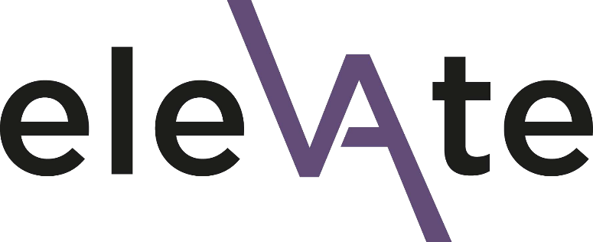

Elevate 2024

Line Manager Endorsement Form

Thank you for taking the time to complete this short form for your member of staff who has applied for a place on the Elevate programme. Your endorsement and active support of the applicant, if they are successful in gaining a place on Elevate, will be essential.
Please complete the form by 23:59 on Wednesday 1st November 2023 at the latest and send it to edi@exeter.ac.uk
Candidates will be informed of the outcome of their application by the end of November 2023. If they are unsuccessful, you will be expected to have a conversation about other development opportunities. They will be provided with supportive and constructive feedback from the selection panel, which can feed into your development conversation. For more information, please see the line manager guidance document.
If you have any questions about the application process, need support in completing it or are experiencing any technical difficulties, please contact Beau Bell, EDI Manager: b.bell@exeter.ac.uk

Data protection
All information you provide in this application form will be treated as confidential and will be held in accordance with GDPR regulations. Please see the University’s privacy notice for further information. Your data will be shared with the selection panel (details available on request) and thereafter used for reporting purposes only.
☐ I consent to my data being used in this way

Applicant and line manager details
Applicant first name
Applicant surname
Your first name
Your surname
Your job title
Your email

Applicant endorsement
Applications will be scored anonymously so please avoid using the applicant's name in your answers to the below questions. Instead, you can say e.g. "this individual".
- Please outline your reasons for supporting the individual in this application (up to 350 words)

- How else are you investing in this person’s development? What support will you give them beyond this programme? (up to 200 words)

Please tick the box to confirm your support for the applicant to participate in the Elevate programme, including attending all programme dates
☐ I confirm the commitment of time, resource and support for participation in this programme

Elevate Sponsor Workshops
Managers and supervisors of participants (or ‘Elevatees’) play an important role as part of the Elevate community, whose active engagement facilitates the success and sustained impact of the programme.
The programme includes two complementary workshops for line managers/sponsors, giving you the opportunity to engage directly with Elevate and experience for yourself the context of this transformative learning environment. They will be led by the Elevate programme facilitators: Dr Peggy Warren and her experienced team from the Ubele Initiative.
- I confirm that I* will attend the two Elevate sponsor workshops on Tuesday 23rd January 2024 (1-4pm, in Bristol) and Tuesday 23rd April 2024 (10am-1pm, online)
*in individual cases a nominated sponsor may be identified, where this is agreed to be more appropriate for local team structures/context. This should be with agreement from the Elevate participant and programme team.

Almost done!
The deadline for completed applications and endorsement forms to be submitted is 23:59 on Wednesday 1st November 2023. Please submit your form to edi@exeter.ac.uk
Please do let your applicant know when you have completed your supporting application.
Applicants and line managers will be informed of outcomes by the end of November.
If your applicant is unsuccessful, you will be expected to have a conversation about other development opportunities. They will be provided with supportive and constructive feedback from the selection panel, which can feed into your development conversation.

The deadline for your line manager to complete the endorsement form is 23:59 on Sunday 23 October 2022.

