Unveiling the Optimal Temperature: A Comprehensive Literature Review on Biological Sample Storage in ULT Freezers

Daniela Farina¹*, Valentina Scagliotti², Andy Evans³

1: Professional Services, University of Exeter

2: Sustainability Consultant - SustainLABility

3: Green Light Laboratories Ltd

*: Correspondence to d.farina@exeter.ac.uk

Introduction
Laboratories serve as vital spaces for Research & Development (R&D) and Innovation departments, but this comes at a cost of significant environmental impact and high energy consumption. Lab spaces consume on average 3-5 times more energy per surface area compared to office spaces or commercial buildings. The main culprits are primarily the energy-intensive Heating, Ventilation, and Air Cooling (HVAC) systems and large equipment such as Ultra-Low Temperature (ULT) freezers, which have to operate at all times [1].
ULT freezers, commonly referred to as "-80s", are crucial instruments for preserving and storing biological samples at extremely low temperatures. They are designed to provide and maintain a controlled environment that ensures the stability and longevity of various biological samples. These freezers play a critical role in scientific research, medical applications, and pharmaceutical endeavours and they are widely utilised in research laboratories, biobanks, clinical settings, and vaccine storage facilities. However, it is important to recognise that maintaining ultra-low temperatures requires a significant amount of energy.
Even the most energy-efficient models available still consume as much energy as an average single- or two-person UK household, equivalent to approximately 8 kWh/day or nearly 3000 kWh per year [2]. For older and less energy-efficient models, the energy consumption can be more than double this amount. Additionally, the recent development of mRNA vaccines, which require ultra-low temperatures for their storage, has resulted in an increase in ULT demand and use.
Therefore, optimising the energy usage of ULT freezers is a key part of sustainable laboratory practices and reducing environmental impact. It is important to consider the temperature requirements for different types of biological samples. While ULT freezers can reach temperatures as low as -86 °C, not all samples require such extreme cold storage. By assessing the storage needs and temperatures required, labs can limit the energy consumption of ULT freezers and make a step towards more efficient and environmentally conscious operations.
In this literature review, we will examine the energy consumption of ULT freezers, comparing the energy usage at -70 °C and -80 °C. We will also provide a concise overview of the existing options for sample storage at temperatures of -150°C or lower; we will explore the temperature requirements for different types of biological samples and discuss strategies to optimise energy efficiency in ULT freezer operations. By synthesising the available literature, this review aims to provide valuable insights into ULT freezers' energy usage and temperature considerations.

The Impact of Operating Temperature on Energy Consumption in ULT Freezers
The energy consumption of ULT freezers is greatly influenced by the set temperature, as achieving and maintaining ultra-low temperatures requires extensive cooling mechanisms. The lower set temperatures, the more energy-intensive cooling processes. In fact, the compressors and refrigeration systems at -80 °C must work harder to remove heat and maintain lower temperatures leading to disproportionately higher energy usage. For this reason, ULT freezers operating at -80°C consume more energy compared to those set at -70 °C.
A short-term study conducted by the University of Edinburgh in 2015 aimed to quantify the energy savings achieved by raising the temperature of ULT freezers to -70 °C [3]. The study utilised three identical ULT freezers (New Brunswick U570 HEF model, all built in 2012). The findings demonstrated an energy reduction of 28% when operated at -70°C when compared to operating at -80 °C. Similarly, a study by the University of Copenhagen observed a 20-22% reduction in the plug load of ULT freezers set at -70 °C compared to -80 °C [4]. Unlike the first study, this test included four different models: small and large chest freezers, and small and large upright freezers, all yielding similar results.
These findings align with reports from ULT freezer manufactures, who have observed a decrease in energy use from the temperature increase to -70 °C ranging between 22 and 26% [5].
Another study analysing the energy consumption of four different ULT models from four different manufacturers set at either -80 °C or -70°C showed reductions in energy usage ranging between 15-29%, depending on the model, when the temperature of the ULT was raised to -70 °C [6].
A notable advantage of ULT freezers set at -70 °C is that their compressors tend to operate less frequently, potentially extending the lifespan of the freezers and reducing maintenance costs. Additionally, ULT freezers operating at -70 °C are expected to generate less waste heat, resulting in lower cooling requirements for the surrounding environment.
Increasing the operating temperature of an ULT freezer is beneficial for the sustainability of operating such equipment, but before ramping the temperature to -70 °C several factors need to be taken into account. Firstly, it is essential to ensure that samples can be safely stored at -70 °C without compromising their integrity. Secondly, frequent opening of ULT freezers can lead to temperature fluctuations, so it is crucial to assess the impact of such fluctuations on sample stability. Lastly, it is important to evaluate the speed at which the temperature increases in case of an emergency breakdown of the ULT freezer to mitigate any potential risks.

2.1. Liquid nitrogen storage and cryofreezers
It is essential to highlight that the long-term preservation of biological samples, particularly living cells, often necessitates storage at temperatures significantly below the glass transition temperature of water (Tg ~135 °C). Below this critical temperature, chemical reactions are effectively halted, and the potentially detrimental process of ice recrystallisation is impeded. Ice recrystallisation is a phenomenon where ice crystals within a frozen sample undergo changes in size and structure, posing a risk of cellular damage and compromising sample quality [7]. Furthermore, ongoing biological reactions may degrade samples under less extreme conditions. As a result, temperatures ranging from -150 °C to -196 °C are the preferred choice for storing cell samples.
Achieving a temperature of -196 °C is only possible by immersing samples in the liquid phase of liquid nitrogen, while the vapor phase maintains temperatures between -150 °C and -180 °C. Due to the health and safety hazards associated with handling liquid nitrogen, this type of cryofreezer necessitates dedicated laboratory spaces and comprehensive personnel training in the safe handling, storage, and disposal of liquid nitrogen. Moreover, these cryofreezers rely on a consistent supply of liquid nitrogen, which can be expensive and contingent on an operational supply chain. Additionally, research has demonstrated a risk of sample contamination when stored in liquid nitrogen tanks [8].
An alternative to liquid nitrogen tanks is mechanical cryofreezers, which can reach ultra-low temperature of -150 °C without the need for a continuous liquid nitrogen supply or dedicated spaces with associated safety requirements. Mechanical cryofreezers should also provide precise temperature control and stability, while eliminating the risk of sample contamination. However, it is important to note that they are very energy-intensive, consuming an average of around 30-35 kWh, making them less energy-efficient compared to liquid nitrogen freezers. Additionally, they are more susceptible to mechanical faults and, most critically, their ability to maintain temperatures below -136 °C in case of a power failing is significantly limited compared to liquid nitrogen cryofreezers (a few hours vs. a few days, respectively).

Finding the optimal temperature for sample storage
As previously stated, ULT freezers have long served as indispensable tools for the preservation and storage of diverse biological samples. The temperature setting within these freezers plays a crucial role in maintaining the stability and viability of the stored samples. Originally, ULT freezers operated at -65 °C or -70 °C, but it wasn't until the 1980s-1990s that advancements in refrigerant technology and insulation materials enabled them to reach a lower set point of -80 °C, which subsequently became the standard [9]. In recent years, there has been a growing trend among institutions and research groups to revert the ULT temperature to -70 °C [9]. However, critics argue that the higher temperature is a threat to sample integrity [10]. Methods used in the past might have been insufficient to detect any differences in sample integrity between storage at -70 °C or -80 °C, but modern laboratory techniques are more sensitive, so more research should be done in order to evaluate storage at -70 °C or, potentially, even higher temperatures. This data could be essential to convince researchers to adopt the new “old” temperature and adapt to evolving sample preservation practices.
While the transition back to -70 °C gains momentum, it is important to highlight the existing studies and resources that shed light on this topic. These valuable sources of information, which are listed below, provide insights into the optimal temperature for sample storage and guide researchers in making informed decisions.

Database from the University of Colorado Boulder
To meet the need for comprehensive data on the efficacy and safety of various sample storage conditions, the University of Colorado Boulder established the first long-term database in 2011 (see 2023 & Future Entries tab). This database encompasses samples stored at +4 °C, -20 °C, and -70 °C. The database includes a wide range of samples, including DNA, RNA, purified proteins, enzymes, growth factors, antibodies, peptides, human sera, cells and cell lines, human and mouse organoids, competent cells and lentiviral stocks, yeast and bacterial stock strains, C. elegans strains, reagent kits, plasmids, vectors, as well as various tissues from mice, rats, humans, and plants. Researchers can freely access the database, which contains valuable information such as sample type, storage duration, ULT freezer model, laboratory details, and specific sample characteristics. To date, no issues have been reported for the samples listed in the database, indicating their successful storage at -70 °C. Only one group has specifically reported that organoids can be safely stored at -70 °C for a duration of up to 2 years. Beyond this timeframe, they recommend transferring the organoids to liquid nitrogen for optimal long-term preservation.

3.2 Literature studies on optimal sample storage conditions
The existing body of literature addressing optimal storage settings and the impact of storage conditions on biological samples is relatively scarce. While some studies have been conducted in this area, the number of publications specifically dedicated to this topic remains limited. Furthermore, the available studies only cover a narrow range of sample types. However, it is important to note that several studies have been conducted over extended periods, allowing for more robust and reliable results.
For the purpose of this literature review, the emphasis primarily focuses on studies examining storage temperatures of -70 °C or higher. Table 1 provides a summary of the main findings, with a particular emphasis on DNA and proteins isolated from whole blood and serum, respectively.
Proteins and biochemical analytes isolated from human serum require ultra-low storage temperatures to prevent enzymatic activity and degradation. The studies reviewed here indicate that -70 °C is sufficient to adequately preserve these samples, with just minimal variations observed in a limited number of analytes when compared to fresh samples [11]–[14].
Unlike protein, DNA samples do not require ultra-low temperatures (-70 °C or lower) and can be safely stored at -20 °C [15]. In fact, no significant differences have been observed in terms of sample integrity and performance between samples stored at -20 °C and those stored at -70 °C or -80 °C [16]–[19]. Compared with ULT freezers, freezers designed to operate at -20°C are more energy-efficient, typically consuming only around 1-4 kWh. Therefore, it is advisable to avoid unnecessary storage of DNA samples at ultra-low temperatures, optimizing the utilization of ULT freezer space. In some cases, DNA can also be stored at higher temperatures, such as +4 °C or room temperature (RT), for short periods of time (< 6 months), although it should be noted that samples are more prone to degradation and will gradually evaporate [18].
In addition to DNA and proteins, fungal strains have also been successfully preserved at -70 °C, with no significant impact on the recovery success rate of the isolates [20].
To preserve the quality and the liveability of living cells samples, temperatures of -150 to -196 °C are required, particularly for long-term storage [21], [22]
Overall, while the available literature may be limited, the studies examined in this review provide valuable insights into the optimal storage conditions for specific sample types, highlighting the importance of considering temperature requirements to ensure sample integrity and preservation.

Biological material tested | Sample source | Temp tested | Study duration and timepoints | N samples | Recommended storage Temp (°C) | Techniques used | Comments | References
DNA | Bacterial Microbiome from Equine Faeces | -20 °C, -80 °C | 4 years | 8 samples (in duplicate) | -20 °C | PCR and Targeted Sequencing (Illumina MiSeq) | Comparable results in terms of alpha and beta diversity. | [16]
DNA | Bacterial Microbiome from Spider Monkey Faeces | RT (Ethanol, RNAlater, FTA Card), -20 °C, -80 °C | 8 weeks | 5 samples combined and aliquoted (1 per condition tested) | -20 °C | PCR and Targeted Sequencing (Illumina MiSeq) | -20 °C and -80 °C are the most effective and stable preserving methods | [17]
DNA | Human whole blood (Dried Blood Spots) | RT, -20 °C | Up to 10 years  2, 5, 10 years | 45 samples (three different concentration ranges) | -20 °C | Nested PCR | -20 °C maintains better sensitivity for PCR, particularly for long-term stored samples | [15]
DNA (high quality genomic) | Human whole blood | RT, +4 °C, -20 °C, -80°C | Up to 2 years  9, 12, 18, 24 months [-20 °C, -80 °C];  3, 6, 9 months [+4 °C, RT] | ? (2 concentrations). | -20 °C | PCR and Single Nucleotide Polymorphisms (SNPs) Analysis | DNA stable for:  24 M [-20 °C;-80 °C];  12 M [+4 °C, with some evaporation]  6 M [RT, TE buffer, evaporation issues];  3 M [RT, dry] | [18]
DNA/mRNA | Human whole blood (liquid + bloodstains) | RT, +4 °C, -20 °C, -80°C | 20 years | 6 samples (tested for all different sample preparation and storing conditions) | -20 °C | Leuco-malachite-green test, immunochromatography, Real-Time PCR, Short Tandem Repeats (STR) typing | No significant differences between samples stored at -20°C or below and fresh samples. Bloodstains stored at RT and +4 °C were significantly more degraded. | [19]
DNA | Human whole blood | RT, -30 °C | 20 years | 2758 samples | -30 °C | DNA quantification and gel electrophoresis | No differences between fresh samples and samples stored at -30 °C | [23]
Proteins: Paraoxonase-1 (PON1, High-Density Lipoprotein- Cholesterol (HDL-C) | Human serum | -20 °C, -70 °C, -196 °C | Up to 1 year  0.1, 0.5, 1, 2, 6 and 12 months | 16 samples | -70 °C | ELISA | Decreased concentration to 96% and 94% for PON1 and HDL-C, respectively, after 6 M at -20 °C | [11]
Proteins:  Antioxidant status (TAS, TAS2, BAP, EAOC) | Human serum | -20 °C, -70 °C/-80 °C, -196 °C | Up to 1 year  0.25, 1, 3, 6, 9, 12 months (+ 0.1, 0.5 for TAS) | 16-34 samples | -70 °C for long-term.  -20 °C accepted up to 1 year | Spectrophotometric analysis | Small decrease in enzymatic activity at 12 M for samples stored at -20 °C | [12]
Proteins:  Plasma antibodies against HIV, HCV, HBsAG  HIV, HCV RNA | Human serum | -20 °C, -70 °C | Over 20 years | 18 samples | -70 °C | Western and RIBA blot. Nucleic acid testing (NAT). | Samples stored at -20 °C prior to 1997. | [13]
Proteins and biochemical analytes (N=21) | Human serum | -70 °C | Up to 15 years | 60 samples | ? | Enzymatic, colorimetric, Electrochemiluminescence, Enzyme-kinetic assays, Kinetic test | Increased/ decreased levels for some analytes after long-term storage | [14]
Yeast and yeast-like organisms, molds | Fungal strains | -70 °C, -196 °C | Up to 4 years  1, 6 months, then every year | 6198 yeast and yeast-like organisms, 391 moulds | -70 °C | Isolates recovery | Similar temperature effects on isolates recovery. | [20]
Peripheral blood mononuclear cells (PBMC) | Human blood | -80 °C, -135 °C, -150 °C, -196 °C | Up to 2.4 years  1-1.5 years, 2-2.4 years | 10-11 samples per temperature | -80 °C or higher for <1 year  -150 °, -196 °C for >1 year | Recovery-viability index and CFU-GEMM assay | Similar temperature effects on recovery viability index. Decreased CFU-GEMM for samples stored at -80 °C and -135 °C for > 1 year | [21]
Algal cells | Chlorella vulgaris | -15 °C, -80 °C, -196 °C | Up to 4 months  24 hours, 1, 4 months | 3 samples per each temperature and timepoint | -196 °C | Simple re-grow assay and viability level | Samples stored at -80 °C maintain the ability to regrow, but viability level rapidly decreases for samples stored at -80 °C | [22]
Table 1. Summary of the literature studies on different storage conditions for biological samples. RT: Room Temperature, M: months

Temperature variations within ULT freezers
Temperature variation within ULT freezers is a critical factor that can impact sample stability and integrity. While ULT freezers are designed to maintain a consistent low temperature, they are not immune to temperature fluctuations. Various factors can contribute to temperature variations within the freezer, including door openings, defrost cycles, compressor performance, racking, and location and distribution of samples within the storage compartments.

4.1 Temperature variations across ULT compartments
ULT freezers can be divided into chest freezers and upright freezers. Chest freezers are known for their superior insulation and better temperature uniformity throughout the storage space, resulting in lower energy consumption compared to upright models [24]. Additionally, the design of a chest freezer allows cold air to naturally sink and stay inside when the lid is opened, minimising temperature fluctuations. However, upright models, which are equipped with multiple shelves and compartments, allow for better sample organisation and accessibility, making them the model of choice for the majority of laboratories. However, upright freezers are more subjected to temperature variations as the cold air escapes each time the door is opened, and each shelf may experience slightly different temperature conditions.
Temperature mapping studies are important to identify any temperature discrepancies between shelves and provide insights into the extent of temperature variations, for example after door opening. These studies utilise temperature probes and online platforms that record all the reading data.
Powell et al. showed that the temperature variations across shelves of ULT freezers set at -80 °C were within an acceptable range (-79.1 °C to -83.17 °C), with no significant differences [25]. In some other instances, however, the temperature variations are higher, as shown by the data reported in Figure 1 (data courtesy of Green Light Laboratories Ltd, unpublished).
This study examines the temperature performance of two distinct ULT models: the Stirling Ultracold SU78XLE (Fig.1A-B) and the Thermo Fisher TSX600V (Fig.1C). The findings reveal significant deviations between the actual temperatures inside the ULT freezers and their setpoints. In the case of the SU78XLE model, the average actual temperatures were consistently 1.7-10.8 °C lower than the setpoint (Fig.1A-B). Conversely, the TSX600V model displayed average actual temperatures that were 2.3-6.0 °C higher than the setpoint (Fig.1C). Notably, the coldest temperatures were observed in the middle compartments of both models, suggesting that these compartments should be prioritized for storing samples that are particularly susceptible to degradation.

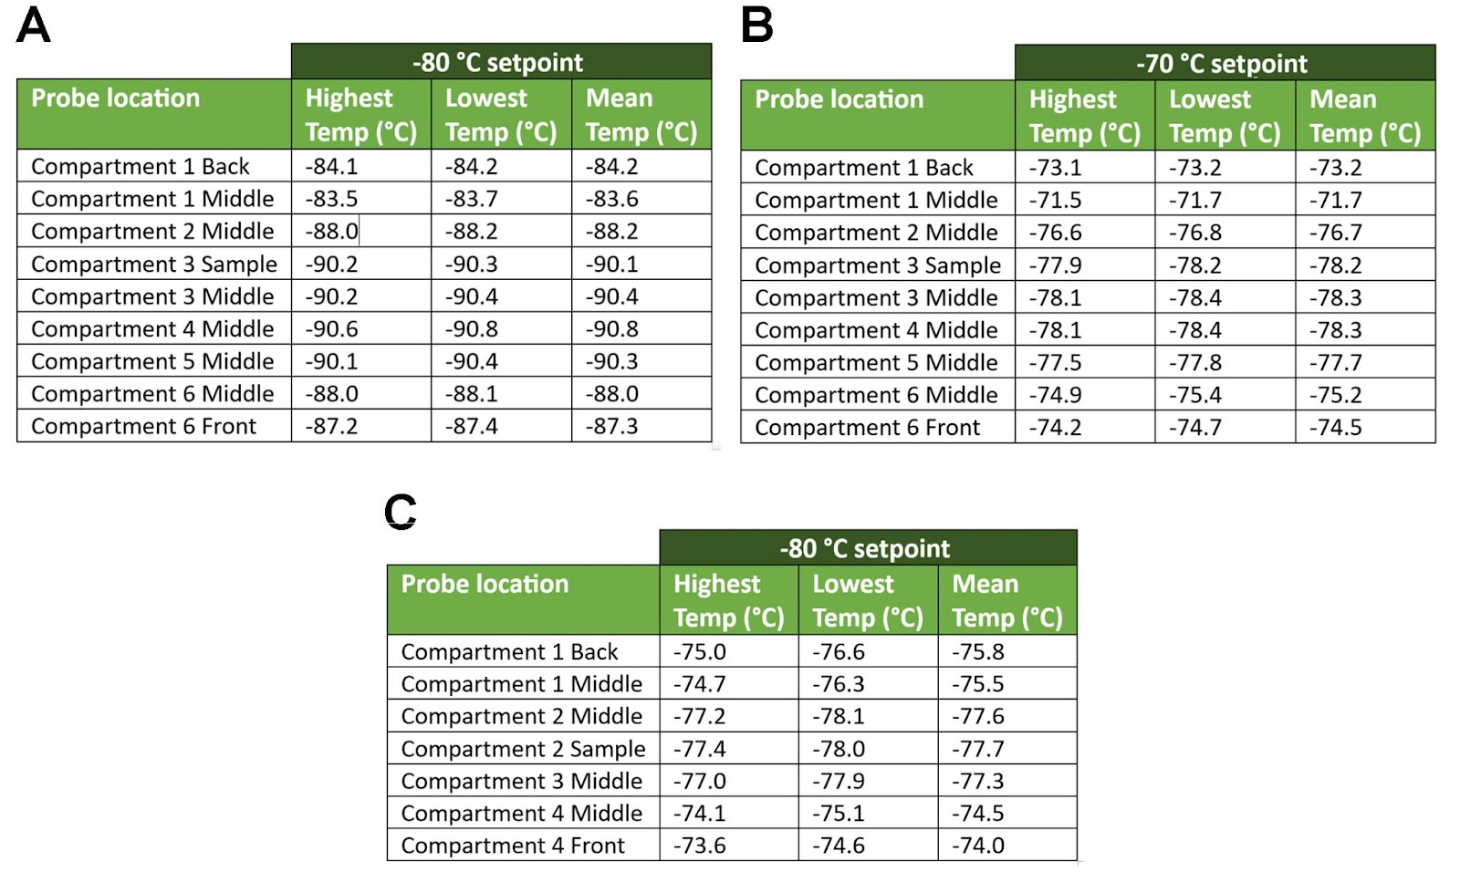
  - Figure 1. Temperature performances of ULT freezers at different temperature setpoints. A-B) SU780XLE temperature performance at -80 °C and -70 °C, respectively. C) TSX600V temperature performance at -80 °C. In each compartment a UKAS calibrated PT1000 probe was placed in the centrepoint of each shelf (figure 1). A sample representative probe (PT1000 probe immersed in 5ml of glycol) was also placed in the centrepoint of the unit. Temperatures of the back of the top compartment and front of the bottom compartment were also recorded. Compartment 1 refers to the top shelf, compartment 6 (compartment 4 in TSX600V) to the bottom shelf).

4.1.1 Door opening
The stability of internal temperature and overall performance of ultra-low temperature (ULT) freezers can be significantly influenced by the frequency and duration of door openings. When the door of a ULT freezer is opened, warm air from the surrounding environment enters, causing temperature fluctuations and potential harm to stored samples. The impact of door openings is particularly pronounced on the top shelves, as demonstrated by Farley et al. in their study [3]. They found that the top shelf experienced the widest temperature fluctuations following ULT door openings. Specifically, when the ULT door was opened for 60 seconds, ULT freezers set at -80 °C or -70 °C saw temperature increases of 8.1 °C and 3 °C, respectively, in the top shelf. In contrast, the bottom and middle shelves exhibited temperature increases of only 3.1-3.4 °C (-80 °C ULT) and 0.1-0.5 °C (-70 °C ULT). These findings are consistent with the observations made by Green Light Laboratories Ltd, as depicted in Figure 2 (data unpublished). The study involved both extended (60 seconds, 90 seconds) and repeated door opening tests (nine 60-seconds door openings at one-hour intervals).
The data analysis reveals that extended door openings can lead to temperatures above -50 °C in the top shelf of ULT freezers configured at -70 °C. It is important to note, however, that these findings were obtained under controlled conditions using empty ULT freezers. In real-world scenarios, with the presence of stored samples, it is expected that the temperature would remain below the critical threshold of -50 °C. Therefore, while caution should be exercised to minimize door opening duration, it is reasonable to anticipate that the actual temperature in the top shelf of ULT freezers, set at -70 °C, would still be maintained within the acceptable range for sample preservation.
At the same time, the data clearly indicates that the middle and bottom compartments of ULT freezers offer the most stable storage conditions, with minimal temperature fluctuations.

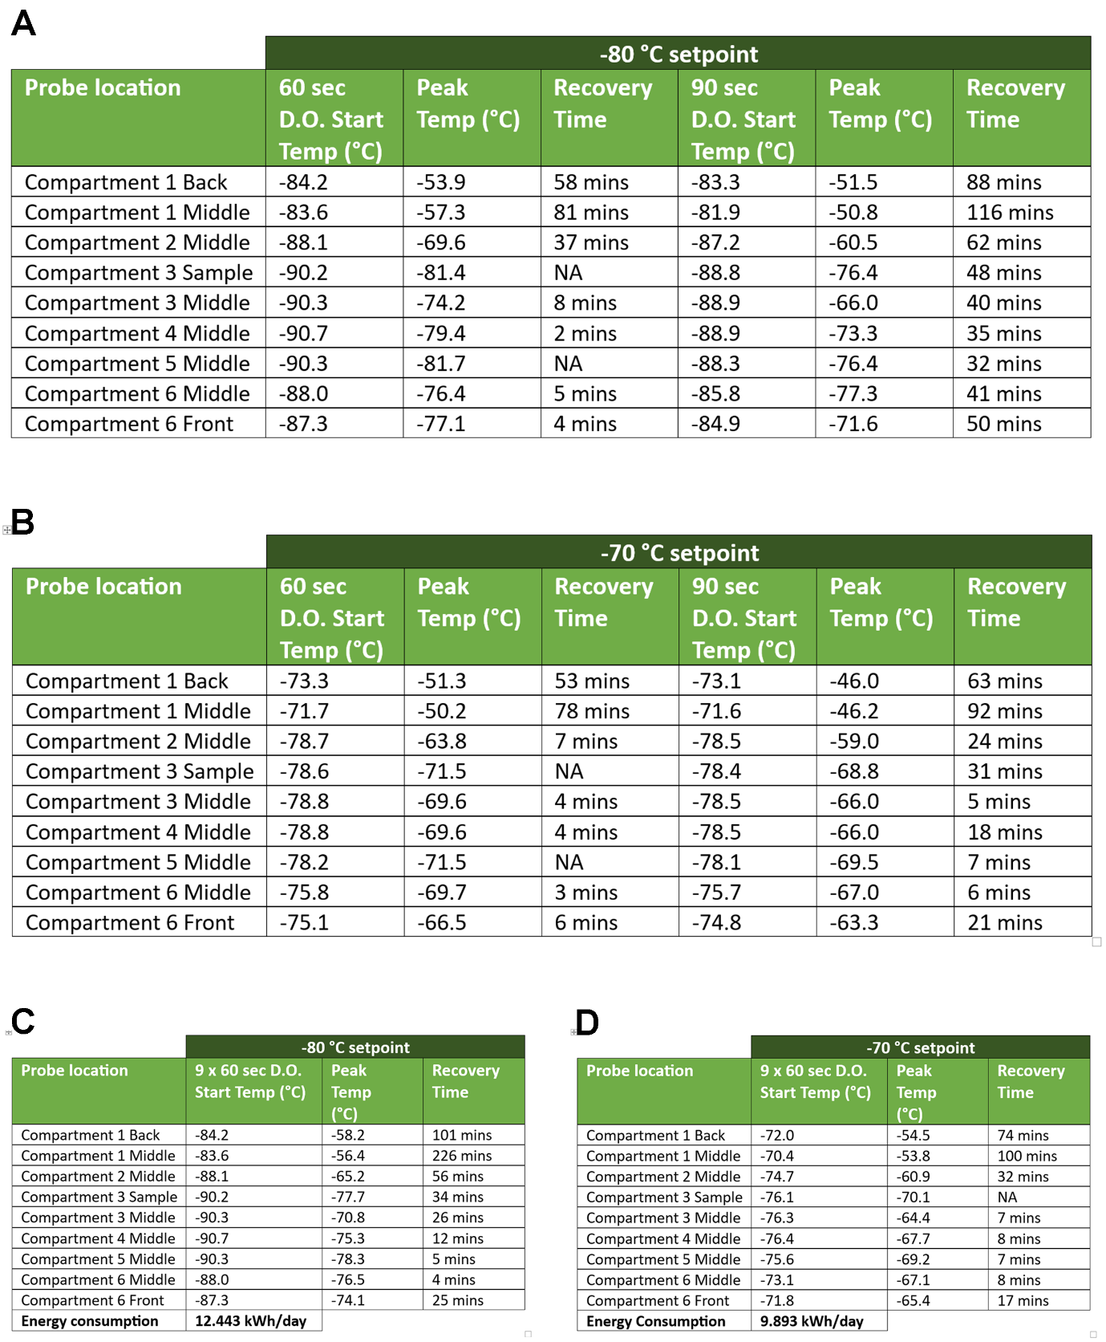
Figure 2. Temperature performance and recovery time following door openings of a SU78XLE ULT freezer at different setpoints. A-B) Door opening (D.O.) recovery data at -80 °C and -70°C setpoint, respectively, after opening the door for 60 seconds and 90 seconds. C-D) Door opening recovery data at -80 °C and -70 °C setpoint, respectively, after opening the door 9 times for 60 seconds (with 1-hour intervals between openings).

4.1.2 Racking
The speed of temperature variations within ultra-low temperature (ULT) freezers is influenced by the racking of samples. When freezers are equipped with racks, the temperature rises that occur after a door opening are significantly reduced. A study conducted by Green Light Laboratories Ltd, commissioned by Scientific Laboratory Supplies and Eppendorf UK, examined the impact of racking on temperature performance. The results were remarkable, showing that temperatures in non-racked ULT freezers can increase over six times more compared to racked freezers [26].
When arranging samples on racks, it is important to optimise the use of space while ensuring adequate air circulation around the samples. Placing sample containers too close together or overcrowding the shelves can restrict airflow and lead to uneven temperature distribution within the freezer. It is recommended to leave sufficient gaps between sample containers and avoid blocking air vents or circulation fans. Additionally, arranging samples in a logical and systematic manner, such as by labelling and categorising them, helps streamline retrieval and minimise the time spent searching for specific samples.
In conclusion, minimizing the frequency and duration of door openings is crucial to reduce temperature variations in ULT freezers. Racking samples can also be beneficial in achieving the goal of temperature stability. Furthermore, careful consideration should be given to the storage location of samples, as the top shelves are most susceptible to temperature fluctuations.

The effects of freeze-thaw cycles on sample integrity
The storage temperature is not the only factor that influences sample quality and integrity. Another critical consideration is the occurrence of freeze-thaw cycles, which can significantly impact the stability and viability of stored samples. Freeze-thaw cycles refer to the repeated process of subjecting samples to freezing and subsequent thawing. Each cycle can induce stress and potentially lead to detrimental effects on sample structure, activity, and functionality [27]. Studies have highlighted the vulnerability of genomic DNA to degradation following multiple freeze-thaw cycles, particularly for larger DNA molecules, due to the formation of ice crystals and resulting tension forces during freezing [28]. However, such samples may still be suitable for targeted PCR and Real-Time PCR analyses [18], [28]. Serum metabolomics, especially in lipid-rich samples, have also been shown to be affected by freeze-thaw cycles, with a recommendation to limit cycles to no more than three [29]. However, not all the serum biomarkers appear to be significantly affected by this practice, as some studies have reported minimal to no differences between samples subjected to temperature fluctuations and the control group [30], [31].
It is important to note that the literature on this topic is limited. As a general recommendation, minimizing the number of freeze-thaw cycles by aliquoting the samples is advised.

Warm-up rates of ULTs freezers in the event of power outages or freezer failures.
A common consideration raised when contemplating a temperature set up change from -80 °C to -70 °C in ULT freezers is the potential impact of power outages or freezer failures. The concern revolves around the time required for the freezer to warm up and reach a less extreme temperature in the event of such failures. Since ULT freezers are designed to maintain ultra-low temperatures, a shift to a higher set point could mean a shorter warm-up time during power or freezer malfunctions.
To assess the warm-up time, studies often measure the duration it takes for the freezer to reach the threshold temperature of -50 °C. In the study conducted by Farley et al, ULT freezers set at -80 °C showed a warm-up time of 290-350 minutes, while those set at -70 °C had a shorter warm-up time of 205-325 minutes [3]. Another report involving three different ULT models from three different manufacturers revealed a consistent warm-up time of approximately 9 hours for all the tested freezers, when set at -80 °C. In this study, the difference in warm-up time between -80 °C and -70 °C conditions ranged between 1.5 and 2.8 hours [6].
While the potential time lost during warm-up should be taken into consideration, it is important to note that with proper alarm systems and contingency measures in place, switching to -70 °C still allows sufficient time to safely transfer the stored samples to a backup freezer if a power outage or freezer failure occurs.

Conclusions
In summary, this literature review highlights that a storage temperature of -70 °C can be considered as a viable alternative to the traditional -80 °C, with many institutes already making the switch to higher temperatures [9]. Studies have also shown that, for DNA samples, -20 °C storage is sufficient [15]–[18], while proteins and biochemical analytes in human serum require ultra-low temperatures for optimal preservation [11]–[14]. One of the significant positive aspects of storing samples at -70 °C is the potential for improved energy efficiency and cost savings compared to traditional -80 °C storage. The slight increase in storage temperature from -80 °C to -70 °C can result in reduced energy consumption and lower operating costs for ULT freezers. This can be particularly beneficial for research institutions and laboratories with large-scale sample storage needs, as it allows for a more sustainable and economical approach without compromising sample integrity. Additionally, the adoption of -70 °C as a storage temperature may contribute to reducing the overall environmental impact associated with ultra-low temperature storage, aligning with efforts to promote sustainable laboratory practices.
Additionally, temperature variations within ULT freezers, door openings, freeze-thaw cycles, racking, and warm-up rates are all factors that can influence sample stability and viability. Understanding these factors is crucial for maintaining sample integrity and ensuring reliable experimental results.
Proper management of ULT freezers, including minimizing door openings, optimizing racking to allow for adequate air circulation, and limiting the number of freeze-thaw cycles, is crucial for maintaining temperature stability and sample quality. The middle and bottom compartments of ULT freezers have been shown to offer the most stable storage conditions, with the least temperature fluctuations.
It is important to note that the literature reviewed here provides valuable insights into the impact of storage conditions on sample integrity, but more research is needed to cover a wider range of sample types and storage conditions. Researchers should continue to explore new approaches, technologies, and protocols to enhance sample storage practices and minimize the potential risks associated with sub-optimal storage conditions.
One potential approach is to store samples in duplicate at both -80 °C and -70 °C, allowing for parallel analysis and comparison. Alternatively, the samples can be kept at -80 °C as a backup while conducting experiments and analyses on the samples stored at -70 °C using the desired techniques. This dual storage strategy provides researchers with the flexibility to explore the effects of different storage temperatures while maintaining the security of backup samples at the ultra-low temperature of -80 °C.
In conclusion, the adoption of a storage temperature of -70 °C in ULT freezers, along with an optimised utilisation and management practices, offers several advantages including improved energy efficiency and cost-effectiveness, and reduced carbon emissions, compared to -80 °C. Importantly, all this is achievable without compromising sample quality and research outcomes. By embracing the -70 °C temperature range, researchers can achieve optimal storage conditions while making sustainable choices, leading to a greener and more economical approach to sample preservation.

References
[1] L. Hopkinson, P. James, N. Lenegan, T. McGrath, and M. Tait, ‘Energy Consumption of University Laboratories: Detailed Results from S-Lab Audits’, 2011.
[2] Ofgem, ‘Average gas and electricity use explained’. https://www.ofgem.gov.uk/information-consumers/energy-advice-households/average-gas-and-electricity-use-explained
[3] M. Farley, B. McTeir, A. Arnott, and A. Evans, ‘Efficient ULT freezer storage. An investigation of ULT freezer energy and temperature dynamics’, 2015.
[4] U. of Copenhagen, ‘Plug load test for ULT Freezers: 20-22% lower energy consumption at-70 ºC compared to-80 ºC’, 2017, [Online]. Available: http://groencampus.ku.dk/detgoervi/konkreteprojekter/groenindkoebsaftale/
[5] Thermo Fisher Scientific, ‘Smart Notes’. https://www.freezerchallenge.org/uploads/2/1/9/4/21945752/06_-_smartnote_-_tsx_efficiency_at_-70c_setpoint.pdf
[6] D. Faugeroux, ‘Ultra-Low Temperature Freezer Performance and Energy Use Tests Stirling Ultracold SU78UE Eppendorf Cryocube 570h Thermo Fisher TSX600’, 2016.
[7] D. E. Pegg, ‘The relevance of ice crystal formation for the cryopreservation of tissues and organs’, Cryobiology, vol. 60, no. 3, pp. S36–S44, Jul. 2010, doi: 10.1016/J.CRYOBIOL.2010.02.003.
[8] F. Bajerski, M. Nagel, and J. Overmann, ‘Microbial occurrence in liquid nitrogen storage tanks: a challenge for cryobanking?’, Appl Microbiol Biotechnol, vol. 105, no. 20, pp. 7635–7650, Oct. 2021, doi: 10.1007/S00253-021-11531-4.
[9] T. Bousema, A. Hunter, K. Ramirez-Aguilar, M. Farly, J. Dobbelaere, and C. Greever, ‘-70 is the new -80’, 2020.
[10] German Biobank Node, ‘Recommendations for the energy-saving use of -80°C ultra-low temperature freezers’, 2022.
[11] P. K. Beekhof, M. Gorshunska, and E. H. J. M. Jansen, ‘Long term stability of paraoxonase-1 and high-density lipoprotein in human serum’, Lipids Health Dis, vol. 11, 2012, doi: 10.1186/1476-511X-11-53.
[12] E. H. J. M. Jansen, P. K. Beekhof, J. W. J. M. Cremers, D. Viezeliene, V. Muzakova, and J. Skalicky, ‘Long-term stability of parameters of antioxidant status in human serum’, Free Radic Res, vol. 47, no. 6–7, pp. 535–540, Jul. 2013, doi: 10.3109/10715762.2013.797969.
[13] P. Garrett, L. Miller, B. Anekella, and M. Manak, ‘Long-Term Stability of Viral Markers in Plasma’, in 24th Clinical Virology Symposium, 2008.
[14] E. Alegre, N. Varo, P. Fernández-Calle, S. Calleja, and Á. González, ‘Impact of ultra-low temperature long-term storage on the preanalytical variability of twenty-one common biochemical analytes’, Clin Chem Lab Med, vol. 60, no. 7, pp. 1003–1010, Jun. 2022, doi: 10.1515/CCLM-2022-0063.
[15] A. Schwartz, A. Baidjoe, P. J. Rosenthal, G. Dorsey, T. Bousema, and B. Greenhouse, ‘The Effect of Storage and Extraction Methods on Amplification of Plasmodium falciparum DNA from Dried Blood Spots’, Am J Trop Med Hyg, vol. 92, no. 5, pp. 922–925, May 2015, doi: 10.4269/AJTMH.14-0602.
[16] S. Gavriliuc, M. R. Stothart, A. Henry, and J. Poissant, ‘Long-term storage of feces at -80 °C versus -20 °C is negligible for 16S rRNA amplicon profiling of the equine bacterial microbiome’, PeerJ, vol. 9, Mar. 2021, doi: 10.7717/PEERJ.10837.
[17] V. L. Hale, C. L. Tan, R. Knight, and K. R. Amato, ‘Effect of preservation method on spider monkey (Ateles geoffroyi) fecal microbiota over 8 weeks’, J Microbiol Methods, vol. 113, pp. 16–26, Jun. 2015, doi: 10.1016/J.MIMET.2015.03.021.
[18] J. Wu, J. Cunanan, L. Kim, T. Kulatunga, C. Huang, and B. Anekella, ‘Stability of Genomic DNA at Various Storage Conditions’, International Society for Biological and Environmental Repositories (ISBER) 2009 Annual Meeting, 2009. https://sels-network.org/wp-content/uploads/2022/09/Copy-of-Stability-of-Genomic-DNA-at-Various-Storage-Conditions-ISBER2009_Bharathi.pdf
[19] M. Hara, H. Nakanishi, K. Yoneyama, K. Saito, and A. Takada, ‘Effects of storage conditions on forensic examinations of blood samples and bloodstains stored for 20 years’, Leg Med (Tokyo), vol. 18, pp. 81–84, Jan. 2016, doi: 10.1016/J.LEGALMED.2016.01.003.
[20] A. Espinel-Ingroff, D. Montero, and E. Martin-Mazuelos, ‘Long-term preservation of fungal isolates in commercially prepared cryogenic microbank vials’, J Clin Microbiol, vol. 42, no. 3, pp. 1257–1259, Mar. 2004, doi: 10.1128/JCM.42.3.1257-1259.2004.
[21] C. R. Valeri and L. E. Pivacek, ‘Effects of the temperature, the duration of frozen storage, and the freezing container on in vitro measurements in human peripheral blood mononuclear cells’, Transfusion (Paris), vol. 36, no. 4, pp. 303–308, 1996, doi: 10.1046/J.1537-2995.1996.36496226141.X.
[22] R. V. Kapoore et al., ‘Effects of cryopreservation on viability and functional stability of an industrially relevant alga’, Scientific Reports 2019 9:1, vol. 9, no. 1, pp. 1–12, Feb. 2019, doi: 10.1038/s41598-019-38588-6.
[23] W. C. Chen et al., ‘The Integrity and Yield of Genomic DNA Isolated from Whole Blood Following Long-Term Storage at -30°C’, Biopreserv Biobank, vol. 16, no. 2, pp. 106–113, Apr. 2018, doi: 10.1089/BIO.2017.0050.
[24] ‘The Most Energy-Efficient Freezer is... A Chest Freezer?!’, 2019.
[25] S. Powell, A. Molinolo, E. Masmila, and S. Kaushal, ‘Real-Time Temperature Mapping in Ultra-Low Freezers as a Standard Quality Assessment’, Biopreserv Biobank, vol. 17, no. 2, pp. 139–142, Apr. 2019, doi: 10.1089/BIO.2018.0108.
[26] A. Evans, ‘Eppendorf F740HI Racking study’.
[27] P. Catriona, ‘Freeze-Thaw Cycles and Why We Shouldn’t Do It’, 2014. https://bitesizebio.com/19700/freeze-thaw-cycles-and-why-we-shouldnt-do-it/
[28] W. Shao, S. Khin, and W. C. Kopp, ‘Characterization of effect of repeated freeze and thaw cycles on stability of genomic DNA using pulsed field gel electrophoresis’, Biopreserv Biobank, vol. 10, no. 1, pp. 4–11, Feb. 2012, doi: 10.1089/BIO.2011.0016.
[29] J. Pinto et al., ‘Human plasma stability during handling and storage: impact on NMR metabolomics’, Analyst, vol. 139, no. 5, pp. 1168–1177, Feb. 2014, doi: 10.1039/C3AN02188B.
[30] H. Haslacher et al., ‘The effect of storage temperature fluctuations on the stability of biochemical analytes in blood serum’, Clin Chem Lab Med, vol. 55, no. 7, pp. 974–983, Jun. 2017, doi: 10.1515/CCLM-2016-0608.
[31] K. Goodman et al., ‘Assessment of the effects of repeated freeze thawing and extended bench top processing of plasma samples using untargeted metabolomics’, Metabolomics, vol. 17, no. 3, Mar. 2021, doi: 10.1007/S11306-021-01782-7.

