Demon of Dartmoor: Mystery beast seen at hell hound's haunt
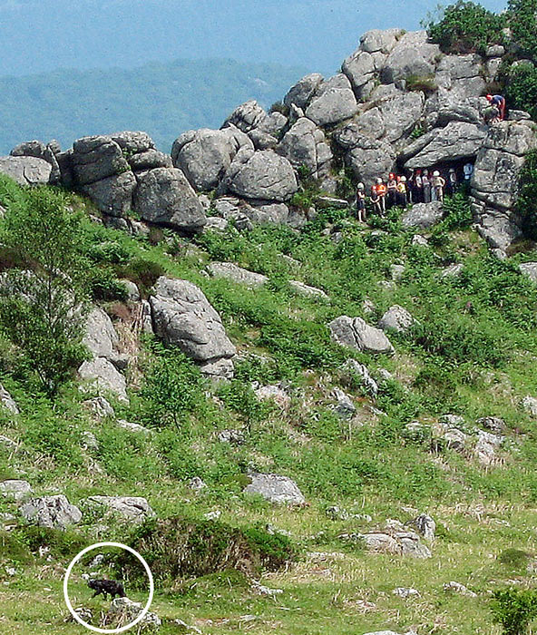
By Rebecca Camber
Legend has it that a four-legged fiend with glowing eyes and a blood-curdling howl stalks this very spot.
Which makes this picture of a mystery creature taken near Hound Tor on Dartmoor more intriguing than ever.
Seen only yards away from a party of schoolchildren, the animal has a thick, shaggy coat, rounded ears and large front limbs which would be powerful enough to tear human flesh.
Some say it is a wild dog or cat. More fanciful theories include wolverine or bear.
Whatever its identity, the Beast of Dartmoor is giving some farmers sleepless nights because they fear it will prey on their stock.
Falconer Martin Whitley, who photographed the creature, said: "It was walking along a path about 200 yards away from me.
"It was black and grey and comparable in size to a miniature pony. It had very thick shoulders, a long, thick tail with a blunt end and small round ears.
"Its movements appeared feline, then bear-like sprang to mind. There was a party climbing on the tor opposite making a racket but it ignored them completely."
A pack of spectral dogs known as the Whist Hounds or Hounds of Hell is said to roam the area according to local folklore, which inspired Sir Arthur Conan Doyle to write the Sherlock Holmes mystery The Hound of the Baskervilles.
The author is said to have been inspired by the legend of Squire Richard Cabell, a keen hunter from Brook Manor, Buckfastleigh.
The squire was rumoured to have sold his soul to the Devil and after he died on July 5, 1677, a phantom pack of black hunting dogs with glowing red eyes is said to have raced across Dartmoor on the night of his interment, breathing fire and howling at his tomb.
According to local legend, the demonic hounds have roamed the moor ever since and can often be seen around the anniversary of his death prowling around the grave trying to get the promised soul for the Devil.
http://www.dailymail.co.uk/news/article-471673/Demon-Dartmoor-Mystery-beast-seen-hell-hounds-haunt.html

