TEACHING ABOUT SENTENCES: SUBJECT KNOWLEDGE FOR TEACHERS’ REFERENCE

Word classes

Words are organised into different word classes according to their function (word classes used to be called ‘parts of speech’ which is best avoided because misleading). They are:
nouns which name things
verbs which express a state of being or an action
adjectives which add more information to a noun
adverbs which add more information to a verb
determiners which limit or define the noun: the, an, my, few, each, its, some etc. (the outdated term for these is articles)
pronouns which take the place of nouns
prepositions which indicate a range of different kinds of meaning e.g. place, time, reason: outside, near, from, into, during, after, with, despite etc. Prepositions are particularly important in building noun phrases e.g. the book on the table by the window in the library
conjunctions link clauses by co-ordination and subordination. Coordinating conjunctions are and, or, but. Subordinating conjunctions include before, after, since, when, once, as long as, etc.

The building blocks of a sentence
Words combine to make phrases:
the Geography teacher … in the staffroom … the daily bulletin
When a verb is added, phrases make clauses:
the Geography teacher was reading (main/independent clause)
the daily bulletin was pinned up in the staffroom (main/independent clause)
reading the daily bulletin… which was pinned up… when he realised (subordinate/dependent clauses)
Clauses combine to make sentences:
The Geography teacher in the staffroom was reading the daily bulletin. (one clause = simple sentence)
The Geography teacher was reading the daily bulletin which was pinned up in the staffroom. (main clause + 1 subordinate clause = complex sentence)
The Geography teacher was reading the daily bulletin, which was pinned up in the staffroom, when he should have been teaching 7AX, who were probably causing a riot by now. (main clause + 3 subordinate clauses = complex sentence)

Types of sentences
- There are four different categories of sentences:
- statements: The children smiled.
- questions: Are you ready?
- commands: Turn round now.
- exclamations: What a shame!

- A sentence can be simple, compound or complex.
Simple sentence:
A sentence containing one clause (known as the main clause or independent clause because it makes sense on its own):
I walked home.
The dark-haired girl in the red shirt hit the ball with a powerful stroke from her newly-strung tennis racket.
The clause contains a finite verb: a verb that changes its form according to tense, number or person:
She walks long distances/She walked long distances/She will walk long distances
The girl hits/The girls hit
I am/You are/She is

Compound sentence:
A sentence containing two or more main clauses of equal weight joined by a co-ordinating conjunctive: and, but, or

I had supper and went to bed.
She hurried home but arrived late.
You can stay in to do your homework or go out with your friends.
(Note the finite verbs)

Complex sentence:
A sentence containing one or more main clauses and one or more subordinate clauses.
A subordinate clause can also be called a dependent clause: it does not make sense on its own but depends for its meaning on the main clause it is placed with. It can move its position within the sentence.
She ran away because she was guilty. (main clause + subordinate clause)
Because she was guilty, she ran away. (subordinate clause + main clause)

There are 3 different ways of forming a subordinate clause:
a subordinating conjunction + finite verb
Until she fell over a hidden tree stump, Louise was well ahead of the other cross-country runners.
or
a relative pronoun + finite verb
It doesn’t matter what I think.
Louise, who was well ahead of the other runners, tripped and fell.
or
a non-finite verb
A non-finite verb does not change its form: it stays the same in a clause, regardless of changes alongside it. There are three non-finite verb forms:
- the –ing present participle: Walking home, I felt concerned.
- the –ed past participle: Locked in his room, Joe lay on his bed and cried.
- the infinitive: To see if he was right, I tested it myself.

Varying sentences
- Sentences can be constructed in different ways to vary impact, e.g.
  - by changing the order of clauses within the sentence
She was startled and looked at her son.
She looked at her son and was startled.
  - by changing the position of the subordinate clause within the sentence, including dropping it into the middle of a sentence, as a bracketed “aside”
Celebrities, judging by the way they are pursued by the tabloids, have no right to privacy.
  - by starting with a non-finite verb
Hurrying, he failed to notice the pothole in the middle of the road.
  - by starting with an adverb
Later, lying in a hospital bed, he replayed the events of that morning.
  - by putting the subject late in the sentence
At the top of the stairs, on the landing, Tom waited.
- Within a paragraph, think about how to vary for impact:
  - the mix of simple, compound and complex sentences
  - the length of simple, compound and complex sentences
  - how the sentence starts

Points to consider:
- there is no intrinsic correlation between a simple or a complex sentence and sophistication in writing
- weak writers tend to use too many finite verbs and to use more coordination (chaining ideas together using and or a comma splice)
- weak writers tend not to be able to control punctuation and sentence length
- able writers use more complex sentences than compound, and are able to use simple sentences for effect. They also deliberately vary the length of sentences and paragraphs (which might include minor sentences (with no verb) or a one-sentence paragraph.

Therefore, we need to teach pupils:
- to avoid over-coordination in sentences
- the use of single-clause (simple) sentences for effect, according to text type
- the inter-relationship between sentence structure and punctuation
- how to sequence ideas and sentences within a paragraph
- to use connectives with attention to meaning, not just as writing prompts

Use shared reading to explore sentence variation and its effect on the reader in a range of text types
Use shared writing to model for pupils how to vary sentences, with an emphasis on discussing language choices and effects

Why teaching sentences and punctuation matters
The following examples are adapted from Debra Myhill’s Better Writers (2001) and illustrate how progression in writing depends on sentence variation:

Text A
Once upon a time there was a little girl and her name was Red Riding Hood and she lived on the edge of a forest with her mother and father. One day Red Riding Hood’s mother called her into the cottage kitchen and Red Riding Hood could smell cakes baking and her mother told her to take the cakes to her grandmother in the forest. Her grandmother was very old and she was not very well and she lived all alone in a cottage deep in the forest. Red Riding Hood’s mother finished baking the cakes and dusted them with icing sugar. So Red Riding Hood filled her basket with cakes and covered them with a red napkin and she set out on her journey.

The tendency to over-use coordination is more typical of lower and middle ability writers. This may reflect speech patterns which are naturally more heavily coordinated; or it may reflect a focus upon conveying narrative action without considering the relationships between ideas that can be expressed through subordination.

Text B
Once upon a time there was a little girl, called Red Riding Hood, who lived on the edge of a forest with her mother and father. One day Red Riding Hood’s mother called her into the cottage kitchen, filled with the smell of baking cakes, and told her to take the cakes to her grandmother. Because she was now old and unwell, and lived all alone in a cottage deep in the forest, Red Riding Hood’s grandmother would be glad of the cakes and the company. Soon, the cakes had been baked and dusted with icing sugar. Then Red Riding Hood filled her basket with them, covered them with a red napkin, and set out on her journey.

Using subordination allows the relationship between clauses to be more explicit: it can represent a move from chaining ideas together (with and or but) to showing explanatory or causal links.
Using subordination results in varying the structure of the sentence, which can add to its impact on the reader. Using subordination often invites the use of more sophisticated internal sentence punctuation.

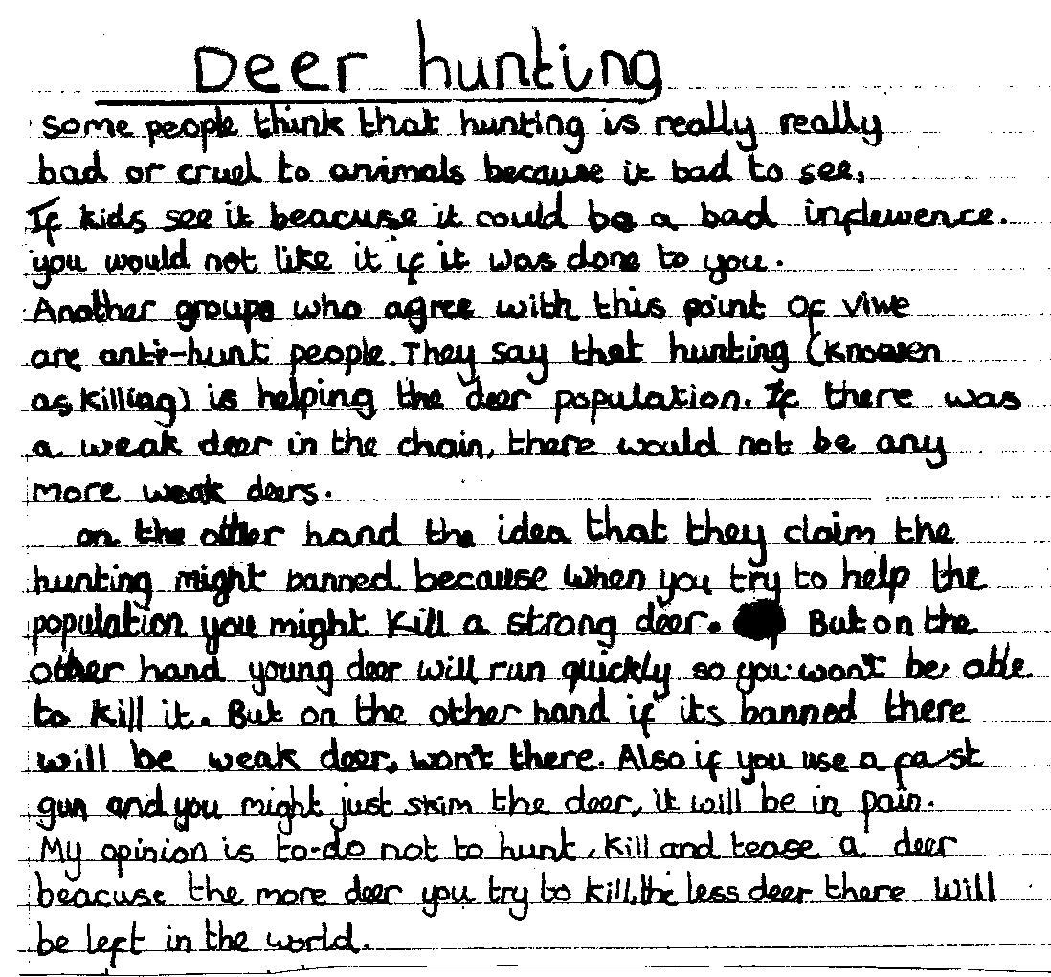

- What is this pupil doing successfully in terms of controlling and varying sentence structures and punctuation?

- How might these aspects of the writing be improved?

