Sequencing a Narrative 2.1
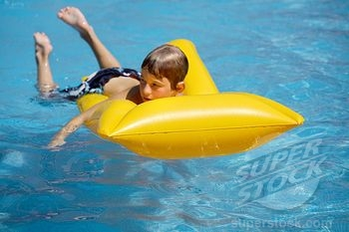

***********************************************************************************
The boy was resting, his arms dangling down, his feet and ankles dipping in and out of the water with each small swell.
***********************************************************************************
The boy noticed that he had been carried out beyond what his mother would consider safe. He began to kick and paddle towards shore.
***********************************************************************************
The boy stopped for a moment to rest. ***********************************************************************************
The boy resumed paddling.
***********************************************************************************
The boy’s last – only – thought was that he had been punched in the stomach. The breath was driven from him in a sudden rush. He had no time to cry out.
***********************************************************************************
The boy’s legs were severed at the hip, and they sank, spinning slowly to the bottom.
************************************************************************************

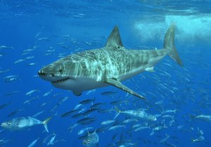

*******************************************************************************
In thirty-five feet of water, the great fish swam slowly, its tail waving just enough to maintain motion.
*******************************************************************************
The fish registered the sharp and jerky impulses emitted by the boy’s kicks. They were signals, faint but true, and the fish locked on them.
********************************************************************************
The fish passed beneath the boy, skimming the sandy bottom. Again it turned.
********************************************************************************
The fish was almost directly below the boy.
********************************************************************************
The fish rose. The mouth opened, and with a final sweep of the sickle tail, the fish struck.
********************************************************************************
The fish’s head drove the raft out of the water. The jaws smashed together.
********************************************************************************

