2.5

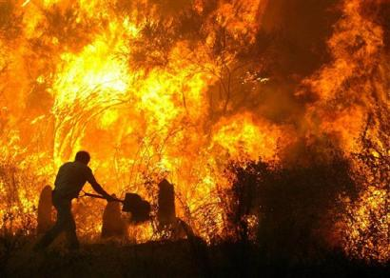
Your aim is to show how hot, fierce and destructive the fire is and how quickly it spreads. Use this grid to gather vocabulary before you craft your paragraph. Make the nouns and verbs do most of the work.

NOUNS | VERBS
fire  flames  sparks  smoke  heat  furnace  forest  branches | crackled  hissed  spitting  shot  licked  raged  leapt  spread

Flames leapt between branches, spitting sparks into the sky…..

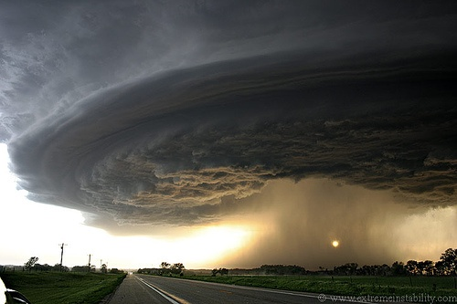
Your aim is to show how powerful and destructive the tornado is and how quickly it moves. Use this grid to gather vocabulary before you craft your paragraph. Make the nouns and verbs do most of the work.

NOUNS | VERBS
tornado  twister  storm  winds  clouds  sky  fields  pylons | gathered  circled  swept  raced  pounding  powered  twisting  sucked

Clouds gathered and raced across the sky….

