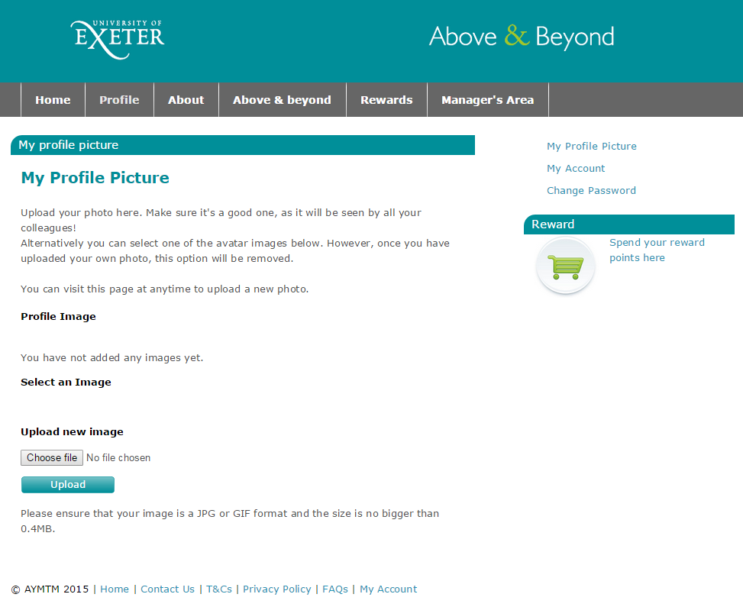
Login – www.exeteraboveandbeyond.co.uk
Setting up your profile picture
1) Click on the ‘Profile’ tab in the grey navigation bar at the top of the page.
Then click on ‘my profile picture’ link from the options on the right

2) To add a new picture, first click on the ‘choose file’ button

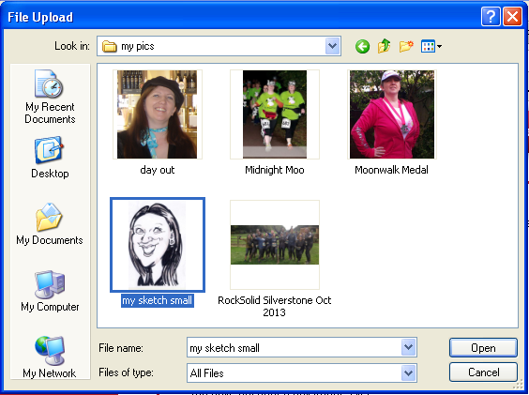3) This will then open a dialogue box where you can browse your computer for a picture – double click on the image you want to upload
(Please ensure that your image is a JPG or GIF format and the size is no bigger than 0.4MB)

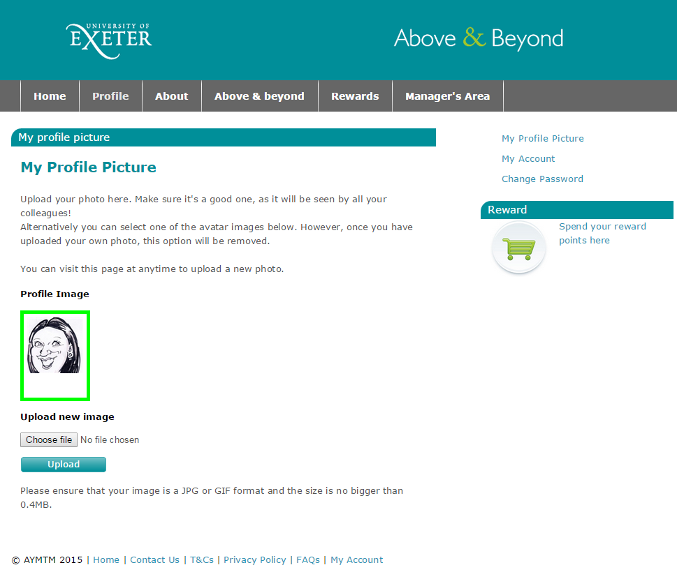
4) This will take you back to your profile page where you can see your image has been selected.
Click on the upload button to load the image to your profile page

5) Once you have uploaded the image you will then be able to crop it to fit by dragging the box frame to size
Finally click on the save image button to set the image as your profile picture

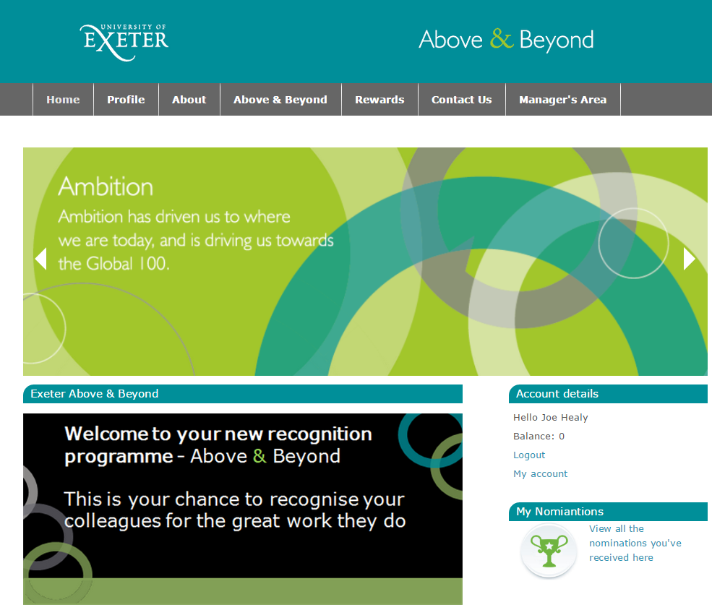
Viewing your nominations
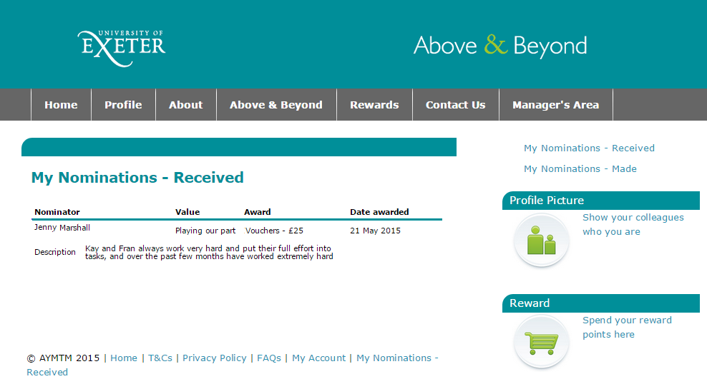
1) Click on the ‘My Nominations’ link on the bottom right of the home page.
Once on the ’my nominations’ page you will be able to view all the details of the nominations you have received and download a copy of your ecard (you will need to ensure pop up blocker is switched off to open the ecard).

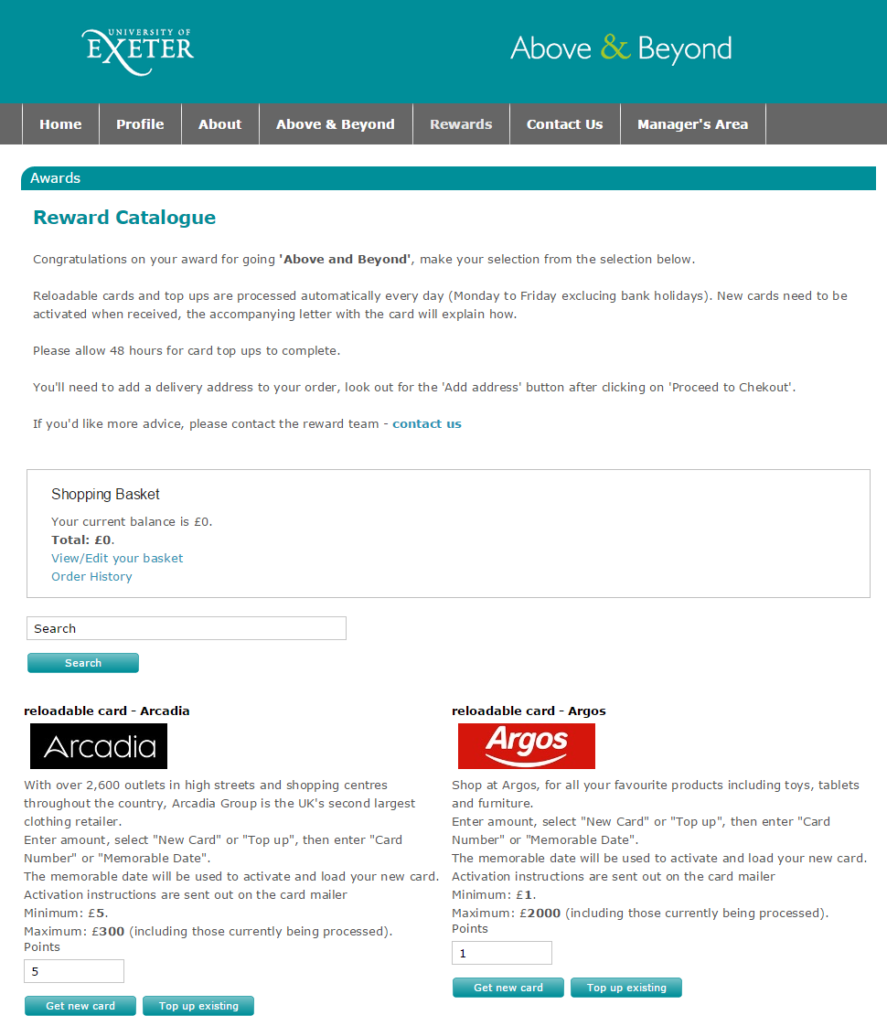
Spending your reward
Click on the ‘Rewards’ tab in the grey navigation bar at the top of the page, this will take you to the reward catalogue where you can choose from a broad range of high street gift vouchers and cards.
You can either search for a specific retailer by name or scroll down the page to see what’s available.
Once you’ve found the voucher you want, just enter the quantity you want to order based on the cost of the voucher (i.e. if you want to order £25 of Asda vouchers and the vouchers are £5 each your order quantity would be 5), then click ‘Add to basket’
You can order as many types of voucher as you like in whatever quantities up to the balance of your reward.
Once you have completed your selection, click on ‘View/Edit your basket’ at the top of the page and follow the check out process – you will be able to specify a delivery address for your vouchers during checkout.
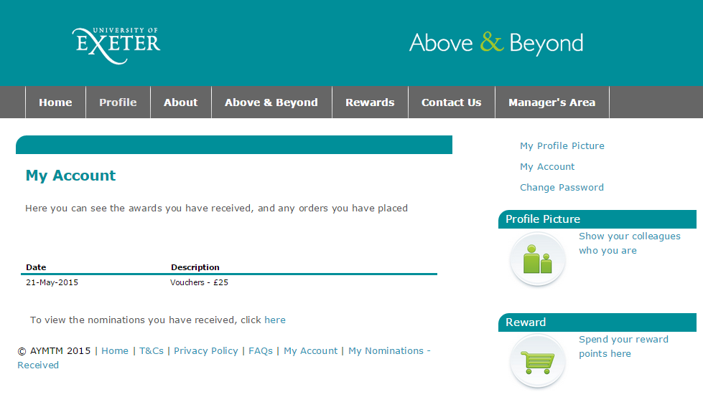
Please be aware that any orders under £50 will be sent by 1st class post while any orders over £50 will be sent by secure delivery and will require a signature.
You can view a record of all rewards you have received and the orders you have placed on the ‘My Account’ page.
The link for this is on the home page and at the foot of every page.

